Create KeySpace for weather_data with replication factor = 3

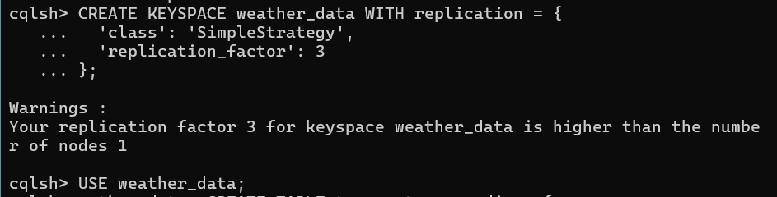

Inside the cluster use the weather_data keyspace and then create a temperature_readings table

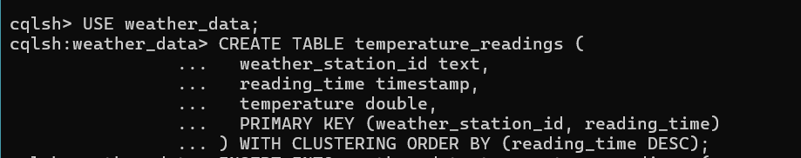

Add some entries in the table

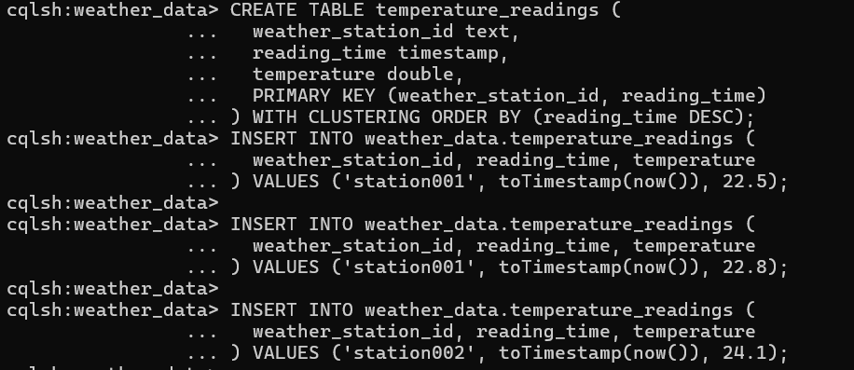

Look at the reading from the station

